**Barbara McCloskey**

Grosz, George (1893-1959)

George Grosz was a leading artist of Germany’s early 20th century Expressionist, Dada, and New Objectivity movements. His works from this period remain celebrated examples of the modernist avant-garde. Grosz began his career as a student at the Dresden Academy of Art in 1909. In 1912, he moved to Berlin, abandoned the academic rigor of his earlier work, and became part of the Expressionist avant-garde. His paintings and drawings soon adopted the fractured planes, vivid color, and psychologically troubled content of Expressionist art.

Grosz became politically radicalised by the outbreak of World War I in 1914. He helped to found Berlin Dada during the war years. His irreverent cut and paste Dada collages of this period assailed not only the concept of ‘art’, but also the vaunted notions of culture, militarism, and national pride that were part of a German social order Grosz had come to despise. At the end of World War I, Grosz joined the German Communist Party and became its leading artist. He fled to the United States in order to escape persecution after Hitler’s appointment as Chancellor in 1933. Grosz settled in New York, where he pursued his art under the utterly changed circumstances of exile.

Grosz became internationally renowned in the 1920s for his illustrations in Communist-affiliated journals and portfolios. His satiric drawings of government, church, and industrial leaders landed him in court three separate times in the 1920s. He also adapted these caricatures to his oil paintings, as in *Sonnenfinsternis* [*Eclipse of the Sun*, 1926]. By 1933, Germany’s nationalist press routinely pilloried Grosz as the country’s ‘cultural Bolshevist #1.’ Sensing growing imperilment, Grosz, his wife Eva, and their two sons Peter and Martin immigrated to New York just days before Hitler came to power.

Though Grosz enjoyed recognition and success in the American art world, he never regained the notoriety of his earlier career. He abandoned Communism, turned away from political caricature, and began to produce large-scale oil paintings of apocalyptic landscapes, grim historical allegories, and disturbing self-portraits. With mounting revelations of Nazi atrocities in Europe and the outbreak of the Second World War, many of these works probed the tragedy of the German culture he fled in 1933 but could not leave behind. Grosz and Eva relocated to Berlin just weeks before his death in July 1959.

**Image (and copyright details):**

George Grosz, *Sonnenfinsternis* (Eclipse of the Sun), 1926. Oil on canvas, 207 x 182.5 cm. Current location: Heckscher Museum, Huntington, New York. Image rights must be secured from VAGA (representatives of the Grosz estate).

VAGA

111 Broadway, Suite 1006

New York, NY 10006

Phone: 212.736.6666

Fax: 212.736.6767

Email: [info@vagarights.com](mailto:info@vagarights.com)

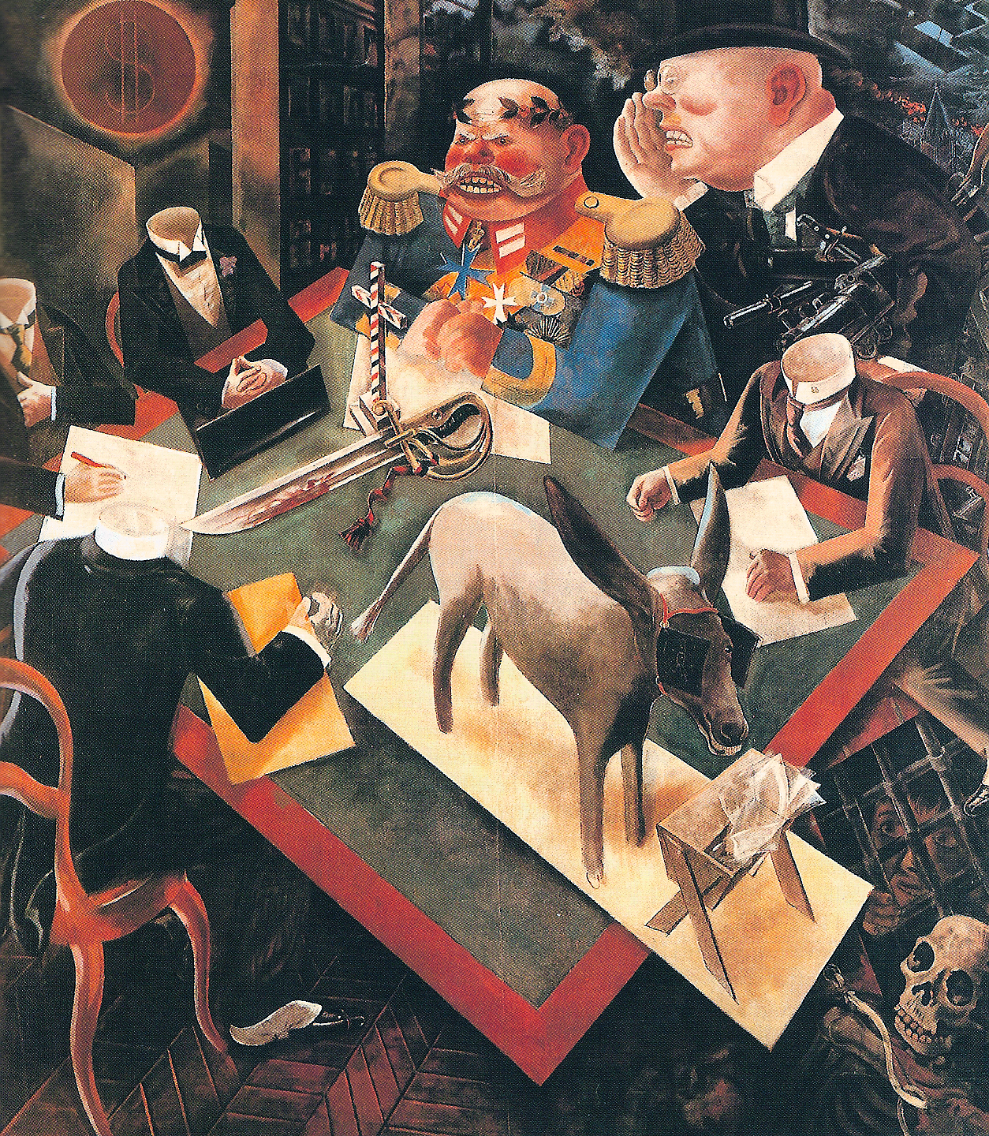

**Sources (114 words)**

Flavell, M. Kay. *George Grosz: A Biography*. New Haven: Yale University Press, 1988.

Grosz, George. *George Grosz: An Autobiography*. Trans. Nora Hodges. Berkeley: University of California Press, 1998.

Lewis, Beth Irwin. *George Grosz: Art and Politics in the Weimar Republic*, 2nd edition. Princeton: Princeton University Press, 1991.

McCloskey, Barbara. *George Grosz and the Communist Party: Art and Radicalism in Crisis, 1918 to 1936*. Princeton: Princeton University Press, 1997.

•Möckel, Birgit. *George Grosz in Amerika, 1932-1959*. Frankfurt am Main: Peter Lang, 1997.

Neugebauer, Rosamunde. *George Grosz. Macht und Ohnmacht satirischer Kunst: Die Graphikfolgen 'Gott mit Uns', Ecce homo, und Hintergrund*. Berlin: Gebr. Mann, 1993.

Schuster, Peter-Klaus, ed. *George Grosz: Berlin-New York*. Berlin: Ars Nicolai, 1994.